

**NORTH SOUTH UNIVERSITY**

**Department of Computer Science and Engineering**

**SPRING 2021**

**Group project: Media Management System platform**

**Group Members:**

* + 1. **Name: Saron ahmed ID: 1821641642**
    2. **Name: Mohammad Hasnath Rashid ID: 1721947042**
    3. **Name: A K M Ihsan kabir ID: 1821886642**

**Course: CSE311**

**Section: 05**

**Instructor: Nadeem Ahmed**

**Lab Instructor: Nazmul Alam Dipto**

**Date of Submission: 19th sep , 2021**

* ***ACKNOWLEDGEMENT***

We would want to take this opportunity to thank God, the Almighty, for blessing us with his favour and bringing our project to a successful conclusion. We express our profound gratitude to our respected guide, NADEEM AHMED SIR(NDA), for giving us sound counsel and direction at critical times, as well as showing me the way. We want to take this time to thank our project coordinator, NAZMUL ALAM DIPTO, for all of his hard work. Last but not least, we'd like to express our gratitude to our friends and family for their support and encouragement during our effort.

* ***ABSTRACT***

1.INTRODUCTION

2. AIMS AND OBJECTIVES

3.BACKGROUND OF PROJECT

4.OPERATION ENVIRONMENT

5.SYSTEM ANALYSIS

6.TABLE DESIGN

7.DATA FLOW DIAGRAM’S

8.MODULE DESCRIPTION

9.SCREEN SHOTS

10.CONCLUSION

11.REFERENCES

* **INTRODUCTION**

What is streaming, exactly? Live or recorded media information supplied via the internet and played back in real-time on computers and mobile devices is referred to as streaming. Podcasts, webcasts, movies, TV shows, and music videos are all examples of streaming content. Music, video, and other types of media assets are pre-arranged and transmitted in a series of data packets so that they may be streamed immediately. Unlike conventional downloads retained on your device, media files are deleted as soon as they are played.

To begin streaming, you'll need a stable and high-speed internet connection, access to or a membership to a streaming service, and a compatible device.

Even more developing and growing number of streaming applications, which will provide a plethora of new content. Streaming applications have a bright future since they provide something for everyone. The greatest option is to use the internet.

* **AIMS AND OBJECTIVES**

If a media management controller wanted to add movie and entertainment content to his streaming website in the many year ago of the Internet, he had to submit it as a link. Visitors to the website were then required to download the file in its entirety before playing it again. With the introduction of live streaming video, this has altered. One of them is our platform, which offers online movie and entertainment material. Content is supplied in such a way that files can start playing practically soon after they start downloading. This live video streaming will broadcast a video stream in real-time to viewers connected to the Internet, allowing users to broadcast an audio or video source in real-time.

A Web user does not have to wait for a file to download before playing it with streaming video or streaming music. A subscribed user can utilize the internet to broadcast or record live events, meetings, functions, and other activities. In the Video Manager, you may also upload and download videos. To see videos, the registered user must pay a membership charge.

* **BACKGROUND OF PROJECT**

Streaming video has revolutionized the way we view videos online by eliminating the need to wait for the video file to download before beginning playing. Broadband is becoming more widely available, which is required for the technology to function effectively.

Streaming videos, especially those of better quality, need a significant amount of bandwidth to play. For HD quality streaming, a minimum Internet speed of 1 Mbps is required. While most cable/DSL connections can support these speeds, individuals with slower connections may encounter difficulties with playback and/or poor quality.

For Free subscribers, copying streaming video files is more difficult, and customers are unable to save a copy to their PC. Only subscription member can record and download streaming videos.

* **Media management platform interfaces:**

• The PHP-based system is linked to a MySQL database.

• To watch live video channels, the system needs an embedded connection.

• Hardware tools, such as a webcam and auto devices, are used to make the system function.

* **User interfaces:**

This project is a client-based web application that assists the administrator in generating income from paying subscribers. Subscribers can post videos in the video manager, future events and live events, and live video stream connections in this system.

* **Hardware interfaces**

• Adobe Flash Player 10.0.42

• Internet Explorer, Firefox 3.0 or higher, Safari 3.0, or Chrome 4.0 or higher

• Microsoft Windows XP or Microsoft Windows 7 as the operating system

• Minimum of 256MB of RAM is required, with 512 MB preferred.

• JavaScript and Cookies must be enabled as well.

• Resolution of Super VGA (800 x 600 pixels) or higher

• Microphone-equipped speakers/headphones

• Web-based camera

**Software interfaces**

* PHP
* MySQL Database Server
* Html & CSS
* Java-scripts
* **Design constraint:**

HTML, CSS, JavaScript, and PHP are the programming languages that will be utilized to code the Live Video Streaming website. The apache server must be installed in order to work on the coding step.

* **SYSTEM ANALYSIS:**

• **Accounts:** This system has two different kinds of accounts. In other words, there are two types of subscribers: those who are free and those who are paying. Users can register in this module by filling up their details. Users may access the accounts page after registering by providing their login id and password.

• **Video manager:** Subscribers may use this module to upload videos and change the description and content of such videos.

• **My Channel:** Visitors may add or subscribe to a user's channel by entering their email address. A mail notice is sent to the visitor whenever the user uploads a new video.

• **Broadcasting of live events:** This module may be used to broadcast live events. It establishes a live link between individuals in different locations for communication, including voice, text, and video. The Live Events and Completed Events modules are included in the Events module. The user must input information such as the event name, date, and time to publish new events.

**• Dashboard module**: In this module, there are two kinds of users. They're both employees and administrators.

**• Live broadcasting module:** A TV tuner or a suitable video embedded connection is required to capture a TV broadcast. Administrators can use this module to broadcast live TV channels by inputting their credentials.

**• Subscription:** This module allows users to pay to subscribe to live streaming. The user can see and record videos when the payment has been confirmed. By pressing the download option, a subscribing member can download the videos.

**• Likes and comments:** Registered users can leave comments and likes on the videos that have been posted.

* **User characteristics:**

Free subscribers, paid subscribers, and administrators who manage the system are the users of the system. Users must have a basic understanding of computers and how to navigate the Internet. The system administrators should have a better understanding of the system's internals and be able to fix minor issues that may emerge from disk crashes, power outages, and other disasters to keep the system running smoothly.

* **Constraints**

• All users' information must be maintained in a database that is only accessible through the media management platform.

• The security mechanism for video streaming must be compatible with Internet browsers.

• The Apache server is connected to the media management platform, which is available 24 hours a day.

• Users may access the media management platform from any computer with Internet browser skills and an Internet connection, as long as they have their usernames and passwords.

* **Maintainability:**

This web application will not require any maintenance. The database is given by the end-user, who is also responsible for its upkeep.

* **Diagram:**

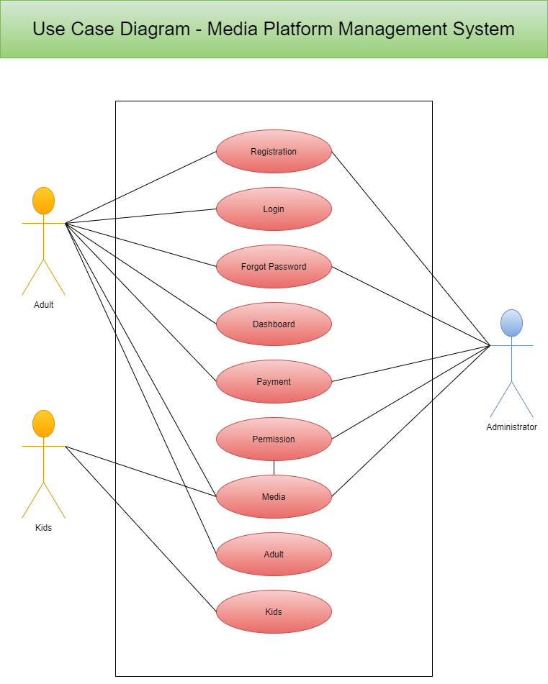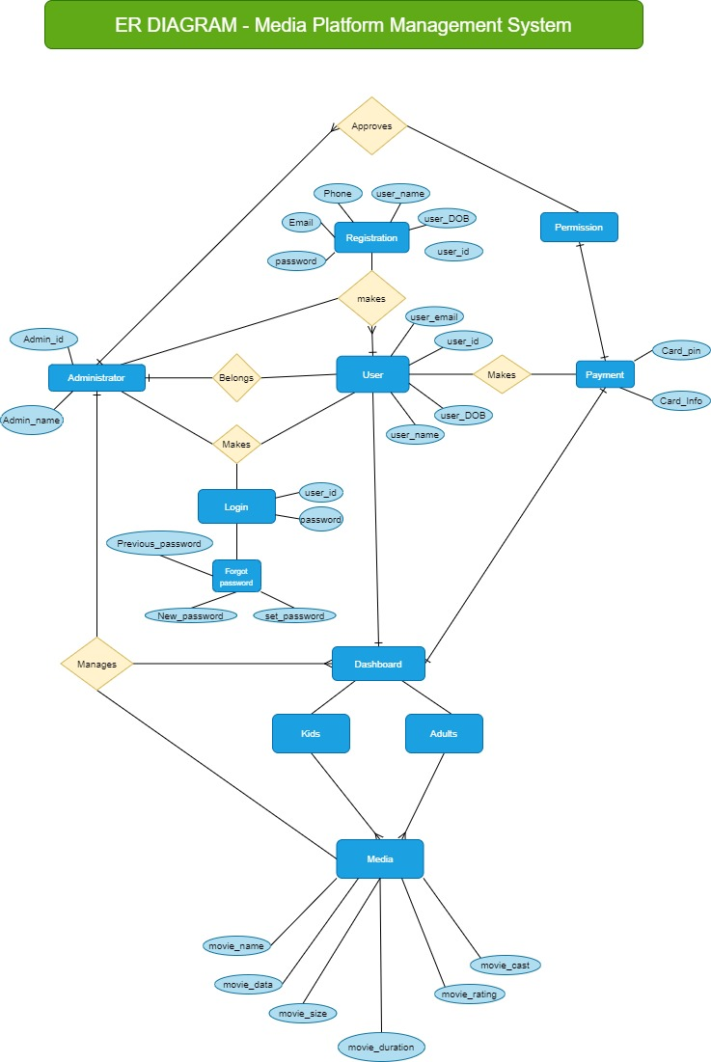

* **Schema Diagram:**

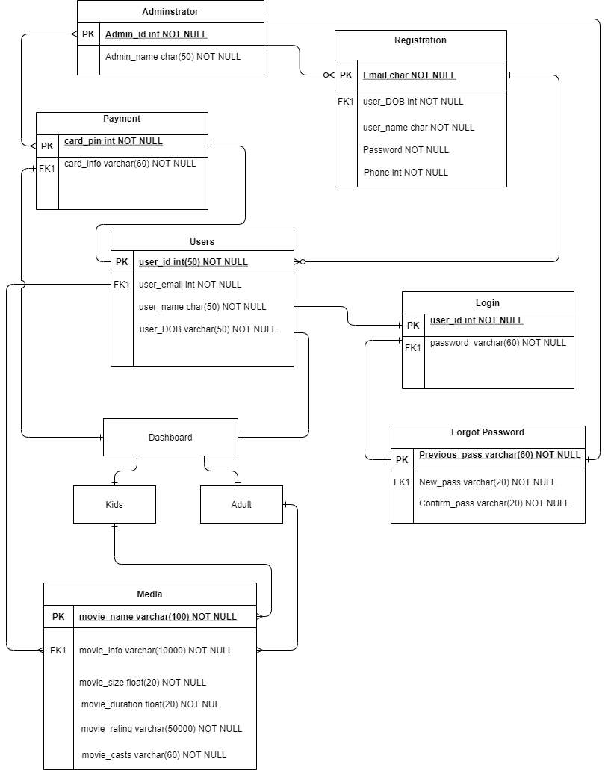

* **RESULT AND DISCUSSIONS**

Implementation is the stage of the work where the theoretical design is transformed into a functional system, providing users confidence in the new system's efficiency and effectiveness. It entails meticulous planning, an examination of the present scenario and its implementation limitations, the development of changeover techniques, and a review of the changeover methods. Aside from planning, education and training of users are essential aspects of the implementation process. The preparation of a plan for the system's implementation is the first step in the process.

According to this plan, actions will be carried out, discussions about equipment and resources will be held, and more equipment will be purchased to execute the new system. No additional resources are required with a network backup solution. The final and most crucial phase is implementation. Giving users trust that the new system will function and be effective is the most critical stage in establishing a successful new system. Only when extensive testing has been completed and determined that the system meets the requirements can it be installed.

This technique also provides the most security since the old system can take over if mistakes are discovered or if the new system cannot handle certain types of transactions.

* **CONCLUSION:**

1. Media Management System platform is, quite simply, a phenomenal service.
2. It has tried to revolutionize the way we watch content, and has conquered the smartphone, tablet, computer and TV.
3. Over the weekend or at the end of a long day, all you really want to do is fire something up on Media Management System platform, sit back and relax.
4. However, it’s worth investigating what's tucked away inside its menus too – there are lots of handy features hidden just under the surface.
5. You can, for instance, explore its many, many secret sub-genres, get access to its newest features before everyone else and even make TV shows and films look better on your screen.

* **FUTURE SCOPE OR ENHANCEMENTS:**

1. Add IMDB Rating to the movie streaming on Media Management System platform.
2. Set Media Management System platform to automatically Pause when you fall asleep.
3. Skip the Spoilers on Media Management System platform.
4. Customize Your Subtitles.
5. Watch Out of Hours for A Smoother Stream.
6. Live Stream Your Reaction or Movie Experience.

* **References:**

[**http://www.w3schools.com/html/html_intro.asp**](http://www.w3schools.com/html/html_intro.asp)

[**http://www.w3schools.com/css/css_background.asp**](http://www.w3schools.com/css/css_background.asp)

[**http://www.w3schools.com/js/js_datatypes.asp**](http://www.w3schools.com/js/js_datatypes.asp)

[**http://www.w3schools.com/sql/sql_insert.asp**](http://www.w3schools.com/sql/sql_insert.asp)

[**http://www.w3schools.com/sql/sql_update.asp**](http://www.w3schools.com/sql/sql_update.asp)

[**http://www.w3schools.com/php/php_forms.asp**](http://www.w3schools.com/php/php_forms.asp)